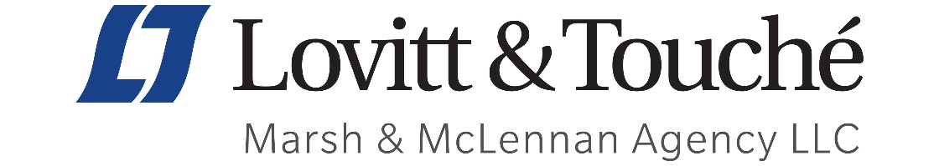

As cyber incidents become increasingly frequent and significantly more devastating, being prepared is more crucial than ever. Marsh & McLennan Agency (MMA) is excited to roll out our Cyber Awareness Month in conjunction with the National Cyber Security Alliance’s theme: “Do Your Part. #BeCyberSmart.”

Check out our resource library and ensure you'll be cyber incident ready:

- Cyber Incident Response Roadmap | Outlines recommended steps to navigate a cyber-incident.
- 10 Cyber Security Controls Recommended by Cyber Insurers | Many leading cyber insurers have imposed minimum security control requirements in order to provide Cyber insurance coverage terms.
- Multi-Factor Authentication Whitepaper | What is MFA and Why Should You Care.
- Cyber security and privacy concerns: COVID-19 | Best practices for clients that may be helpful regarding security and privacy concerns.
- Cyber Resiliency Network | An offering of partner resources to assist with two district areas of cyber risk management:
- Proactive information security and
- Legal components of compliance and risk management
- eRiskHub Portal | Complimentary for MMA clients only; click the link for a demo!

Please reach out today to discuss your cyber insurance coverage and how MMA can take your organization’s cyber-incident preparedness to the next level.

Jennifer Chenault, MA
Vice President
Lovitt & Touché,
A Marsh & McLennan Insurance Agency LLC
7202 E. Rosewood St. Suite 200| Tucson, AZ 85751
p: 520-722-7174 | m: 520-305-0540| f: 520-722-7245
jchenault@lovitt-touche.com | lovitt-touche.com

